Chaperone
2021

- Welcome and information on how to apply
- Job Description & Person Specification
- Application Form
- Equal Opportunities Monitoring Form
- The Theatre Royal in Brief
- How to find the Theatre Royal

[Please save paper – do enjoy reading the following pages, but please only print what you really need. Thank you]

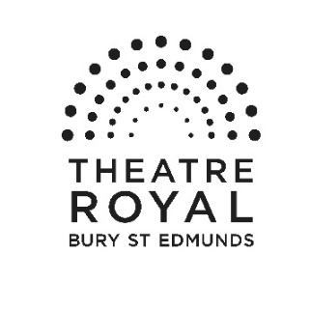

Vacancies at Theatre Royal Bury St Edmunds

Thank you for your interest in joining the team at Theatre Royal. Please find enclosed a job description for the post of Chaperone and some information about Theatre Royal which I hope will encourage you to apply to join us. Further information about the Theatre can be found on our website: www.theatreroyal.org.

If you would like to be considered for this post, please complete and return the application form and accompanying paperwork either

by email to jobs@theatreroyal.org or by post.

Please address your application to

Recruitment, Sharron Stowe, Theatre Royal, Westgate Street,
Bury St Edmunds, Suffolk, IP33 1QR

Good luck and thank you for your interest in working at Theatre Royal.

Yours Sincerely

Owen Calvert Lyons
Artistic Director

Chaperone

Job Description

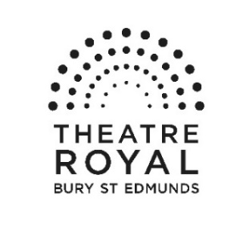

Purpose of post

A Chaperone acts as loco parentis to the child/ren in their care. The Chaperone’s first priority is always to the young person.
The Theatre Royal believes that protecting and ensuring the safety of children, young people and vulnerable adults is the responsibility of all staff. We recognise that as a company we have a moral and legal obligation (duty of care) to contribute to their safety and wellbeing and ensure that all children, young people and vulnerable adults are treated as individuals, so our work can develop their potential in an environment that protects them and keeps them safe from harm.

The Theatre Role has an extensive education programme offering young people the opportunity to take part in a variety of productions. In order to ensure that all young participants are supervised there is a requirement for a pool of licenced chaperones.

This is a zero hours contract

Department: Production Responsible to: Head Chaperone
Works with: Head Chaperone, DSM, Duty Technician, Chaperones

Areas of Responsibility

- To ensure the safety and wellbeing of the Theatre Royal young company, in line with current legislation and safeguarding, during both rehearsals and performances.
- To hold a current valid Chaperone Licence.
- To be up to date and knowledgeable of safeguarding legislation and ensure that any safe guarding issues are reported to the Head Chaperone.
- To undertake Chaperone shifts in accordance with the Chaperone Daily Responsibility procedures.
- To document and log all activity and incidents that occur whilst on duty.
- To accompany the child/ren at all times whilst not on stage.
- To undertake any other reasonable duties as requested by the Head Chaperone

The duties must at all times be carried out with due regard to all Theatre Royal Policies, which are detailed in the Company Handbook.

Person Specification

Essential

- Calm under pressure.
- Good communication skills.
- Able to work with minimal supervision.
- Understanding and regard for Health and Safety.
- Willing to work flexible hours including evenings, weekends and holiday periods.
- Keen awareness and attention to detail.

Desirable
Experience of working with young people.
An existing Chaperone Licence.

Terms & Conditions

Contract: This is a zero hours contract and subject to a one month notice period.

Salary: £8.91 per hour.

Hours of work: This post includes evenings, weekends, daytime and bank holidays.

Place of work: Theatre Royal.

Annual Leave: You will be paid statutory holiday pay.
Allowances: Travel/mileage expenses whilst on Theatre Royal business.

Staff members receive an allocation of complimentary tickets for some performances at Theatre Royal for personal use only.

Pensions: We offer a workplace pension in line with statutory requirements.

Other information: There is a comprehensive staff handbook and induction plan with detailed information on policies, practices and working arrangements offered to all staff.

This position is subject to the receipt of an Enhanced DBS Certificate and a Chaperone’s Licence.

Please read the documents which accompany this form before completing your application.

Once completed, please return the form to jobs@theatreroyal.org

Position Applied for | Chaperone
Where did you see the post advertised

1 Personal Details

Surname
Forename(s)
Address | Postcode
Telephone Number
Mobile
Email address
National Insurance Nº
Do you have the right to work in the UK? | Yes No

2. Why are you applying for this post?

3. What can you offer us?
Please include details of any relevant skills, experience and knowledge (there are later sections for information about training and education)

4 Current or most recent employment/experience of work

Name and address of organisation | Postcode
Position held
Salary (if applicable)
Date appointed
Date left appointment and why (if applicable)

Outline briefly your duties and responsibilities

5 Previous appointments/experience of work

Name and address of organisation | Position held and dates | Main duties and responsibilities | Reason for leaving
6 Training and education
Please include details of exams passed, courses attended and qualifications obtained

7 What else are you interested in?
for example, what are your leisure activities

Where did you see this post advertised? ____________________________________________

8 Additional Information please delete where applicable

Disability: The Equality Act Defines a disabled person as anyone who has, or has had, a physical or mental impairment which has a substantial and long-term effect on their ability to carry out normal day to day activities.
Do you consider yourself to be disabled? Yes No

If Yes please give details and include any arrangements which would facilitate a more comfortable interview if you are shortlisted.

9 Travel
Some positions at the Theatre Royal require employees to drive, if this is applicable to the position you are applying for, please complete this section

Do you hold a current, clean driving licence? YES / NO
Do you have access to/have the use of a car? YES / NO

If the answer to either of these questions is No, please explain how you would meet the travel requirements of the post (where applicable)

10. Confidential Declaration of Criminal Record

Some positions at the Theatre Royal require employees to be responsible for or come into contact with young people aged under 18 and vulnerable adults. If this is applicable to the position you are applying for, you will be required to undertake an Enhanced DBS Check.

Please note that all posts which involve working with young people aged under 18 and vulnerable adults at the Theatre Royal are exempt from the Rehabilitation of Offenders Act 1974, which means that all convictions, cautions, reprimands and final warnings on your criminal record need to be disclosed.

11 References

Please supply the details of two persons (other than relatives) from whom references can be obtained. If you have had previous employment one of your referees should be your current or most recent employer.

Name  Address  email address  Daytime telephone number  Occupation  Employer/Personal Referee (delete as appropriate) | Name  Address  email address  Daytime telephone number  Occupation  Employer/Personal Referee (delete as appropriate)

Are you willing for referees to be contacted prior to interview? YES / NO

12 Declaration

I confirm that the information I have given on this form is correct. I understand that my application may be rejected or that I may be dismissed for withholding relevant details or giving false information.

I understand that, if the position I am applying for is responsible for young people aged under 18 and vulnerable adults, I will be required to complete a Criminal Records Bureau Enhanced Disclosure if appointed.

Signature
Date

Theatre Royal Bury St Edmunds
Built in 1819 by the renowned architect William Wilkins (who also designed the National Gallery in London), Theatre Royal Bury St Edmunds is one of the most significant theatrical buildings in Europe. As this country’s only working example of a playhouse dating from the Regency period, it offers visitors a unique and unforgettable theatrical experience. One of eight Grade 1 listed theatre buildings in the country, it is also the only working theatre in the National Trust’s portfolio of properties. Inspired by its impressive historical pedigree, the Theatre prides itself on the quality and innovation of its artistic work and enjoys a reputation as one of the most forward-thinking arts organisations in the UK.

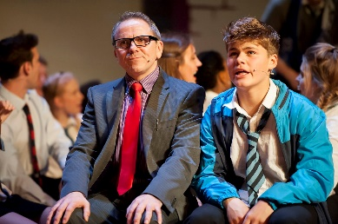
The building itself is owned by the Greene King Brewery. In 1975, it was leased to the National Trust which, in turn, has handed the day-to-day running of the Theatre to Bury St Edmunds Theatre Management Limited. Like many other theatres of its generation, Theatre Royal has enjoyed a chequered history, closing and reopening its doors on a number of occasions. In September 2007, the Theatre reopened following a £5.3 million programme of restoration and development. This project, funded in part by the Heritage Lottery Fund, not only returned the building to its 1819 configuration and decoration but also provided improved customer facilities through the creation of a contemporary foyer space adjoining the Theatre.

With a diverse range of productions the Theatre attracts around 80,000 visitors a year, plus over 2,500 young people and adults engage in creative learning activities in schools or in the community. Over 20,000 people come to see our renowned annual traditional family pantomime plus a wide range of local community and amateur groups regularly present performances on the Theatre’s stage and are essential to the cultural offer to the community.

Theatre Royal celebrates its heritage and, as a National Trust property, welcomes around 2000 visitors a year to enjoy the restored building through guided tours, talks and lectures. The theatre employs a paid staff of 30 and supports a number of internships and apprenticeships, it also has a team of approximately 70 volunteers. It is overseen by a non-executive board of management. There is a Patron's Scheme and a thriving Friends scheme numbering over 600 members. The theatre receives core funding from St Edmundsbury Borough Council and Suffolk County Council and also enjoys strong support from the local business community.

Mission

Theatre Royal Bury St Edmunds presents a high quality programme of performances and creative activities that enrich and inspire children and adults lives.

Aims

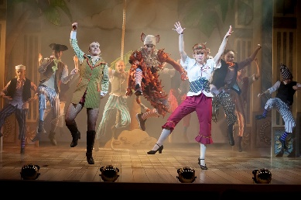
- To present a broad performing arts programme of high quality work from leading arts organisations and emerging artists.
- To work within a range of producing models for Theatre Royal productions.
- To further development of Theatre Royal as a Creative Learning organisation.
- To work within a sustainable business model with a skilled workforce and effective base for its operations
- To develop and grow audiences.
- To build on the trust and support of Theatre Royal’s supporters and stakeholders.
- To celebrate Theatre Royal’s unique heritage.

How to get to Theatre Royal

On arrival, please report to the Box Office at the Theatre.
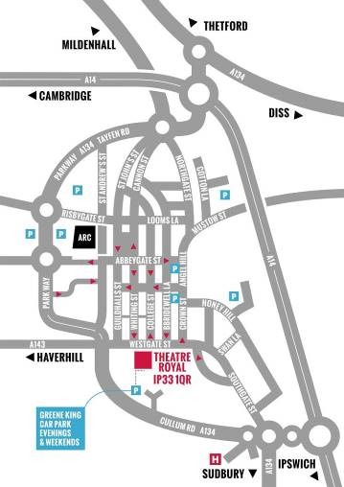
By Road
Bury St Edmunds is just off the A14, east of Cambridge and west of Ipswich. From the Midlands or the East Coast, follow the A14. From London, take the M25 and M11/A11 then A14 heading east (signposted Newmarket / Ipswich / Felixstowe). Approaching from the west, take the third exit for Bury St Edmunds and turn right at the big roundabout towards the town centre. Go right at the next roundabout then right at the third roundabout onto Southgate Street. Follow the road and you will join the one way system; the Theatre is on your left opposite the Greene King Beer Cafe.

Car Parking
The Theatre has no parking of its own. There is very limited parking close to the Theatre. We normally recommend the Angel Hill or Premier Inn car parks as the closest viable options. There are a number of unlimited street parking places on Westgate Street after 6.00 pm.

By Bus
The Bus Station is on St Andrew’s Street North, 10 minutes’ walk from the Theatre. In addition to local services, it is serviced by National Express coach connections from all over the country. Enquiries/Reservations: 01284 702020

By Train
Bury St Edmunds Railway Station is on Station Hill and is 20 minutes’ walk from the Theatre, connecting to Cambridge, Ipswich and the London to Norwich line.
Enquiries/Reservations: 08457 484950

Local Taxis
5 Star Cars 01284 703131 / 01284 704078
A1 Cars 01284 766777
Premier Cars 01284 704004
Star Cars 01284 760707
United Cars 01284 762288 / 01284 764074

Equality and Diversity Monitoring Form

Theatre Royal Bury St Edmunds is committed to a policy of equality of opportunity in all aspects of its recruitment and employment. This includes not discriminating under the Equality Act 2010, and building an accurate picture of the make-up of the workforce in encouraging equality and diversity.

The organisation needs your help and co-operation to enable it to do this. There is no obligation for you to complete the form.

The information submitted will be treated in the strictest confidence.

Please return the completed form to Sharron Stowe

Role
Gender Man Woman Intersex Non-binary Prefer not to say
Are you married or in a civil partnership? Yes No Prefer not to say
Age 16-24 25-29 30-34 35-39 40-44 45-49 50-54 55-59 60-64 65+ Prefer not to say
What is your ethnicity?
Ethnic origin is not about nationality, place of birth or citizenship. It is about the group to which you perceive you belong. Please tick the appropriate box

White
English Welsh Scottish Northern Irish Irish
British Gypsy or Irish Traveller Prefer not to say
Any other white background, please write in:

Mixed/multiple ethnic groups
White and Black Caribbean White and Black African White and Asian Prefer not to say Any other mixed background, please write in:

Asian/Asian British
Indian Pakistani Bangladeshi Chinese Prefer not to say
Any other Asian background, please write in:

Black/ African/ Caribbean/ Black British
African Caribbean Prefer not to say
Any other Black/African/Caribbean background, please write in:

Other ethnic group
Arab Prefer not to say Any other ethnic group, please write in:

Do you consider yourself to have a disability or health condition?
Yes No Prefer not to say

What is the effect or impact of your disability or health condition on your ability to give your best at work? Please write in here:

The information in this form is for monitoring purposes only. If you believe you need a ‘reasonable adjustment’, then please discuss this with your manager, or the manager running the recruitment process if you are a job applicant.
What is your sexual orientation?
Heterosexual Gay Lesbian Bisexual
Prefer not to say If you prefer to use your own term, please specify here ……………………………………………….….

What is your religion or belief?
No religion or belief Buddhist Christian Hindu Jewish
Muslim Sikh Prefer not to say If other religion or belief, please write in:
What is your current working pattern?
Full-time Part-time Prefer not to say

What is your flexible working arrangement?
None Flexi-time Staggered hours Term-time hours
Annualised hours Job-share Flexible shifts Compressed hours
Homeworking Prefer not to say

Do you have caring responsibilities? If yes, please tick all that apply
None Primary carer of a child/children (under 18)
Primary carer of disabled child/children
Primary carer of disabled adult (18 and over) Primary carer of older person
Secondary carer (another person carries out the main caring role)
Prefer not to say

